**Lab 9A**

**Lab 9a - Code**

**IC1_SodaCan.py**

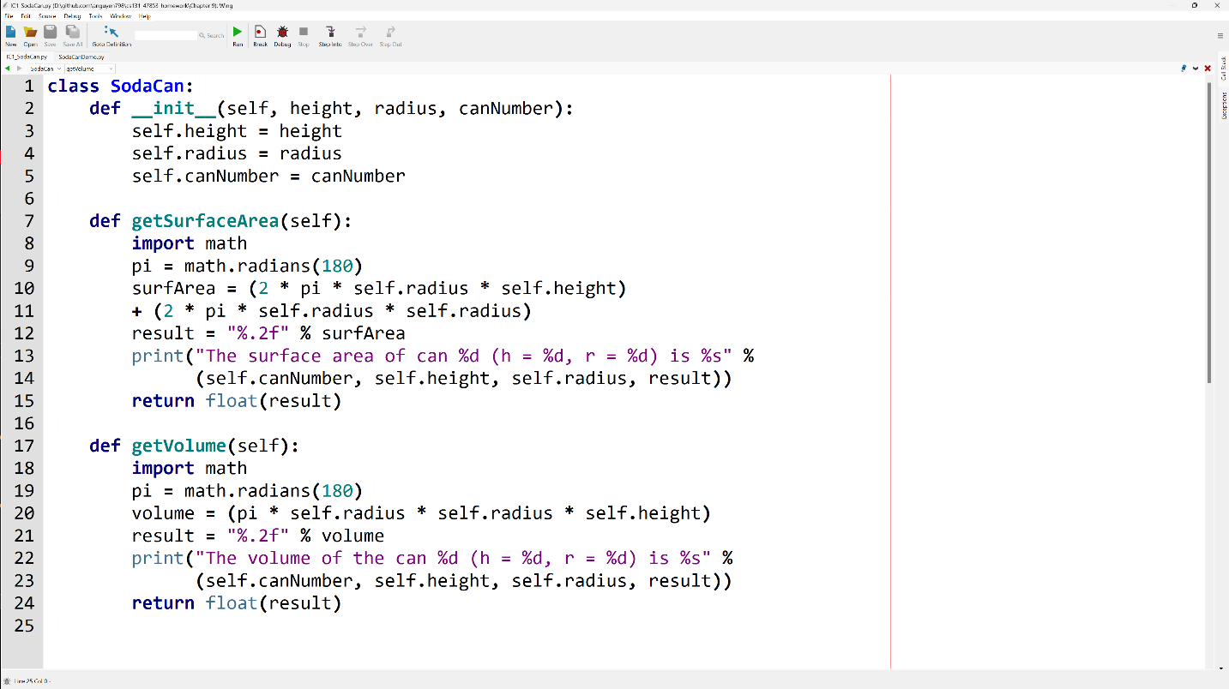

**SodaCanDemo.py**

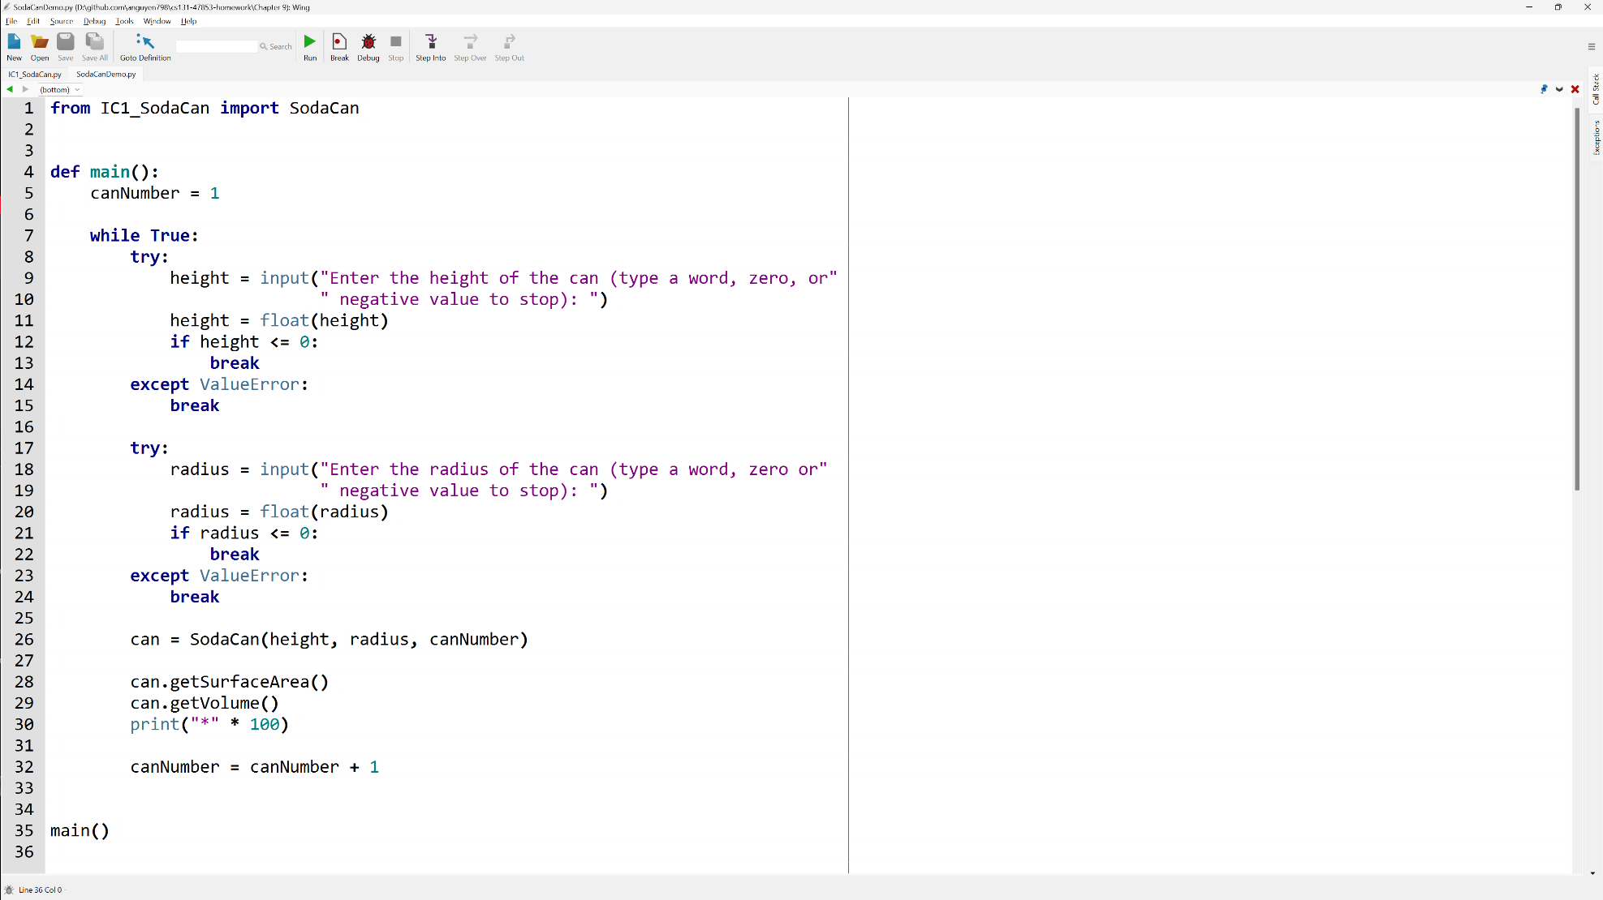

**Lab 9 - Output**

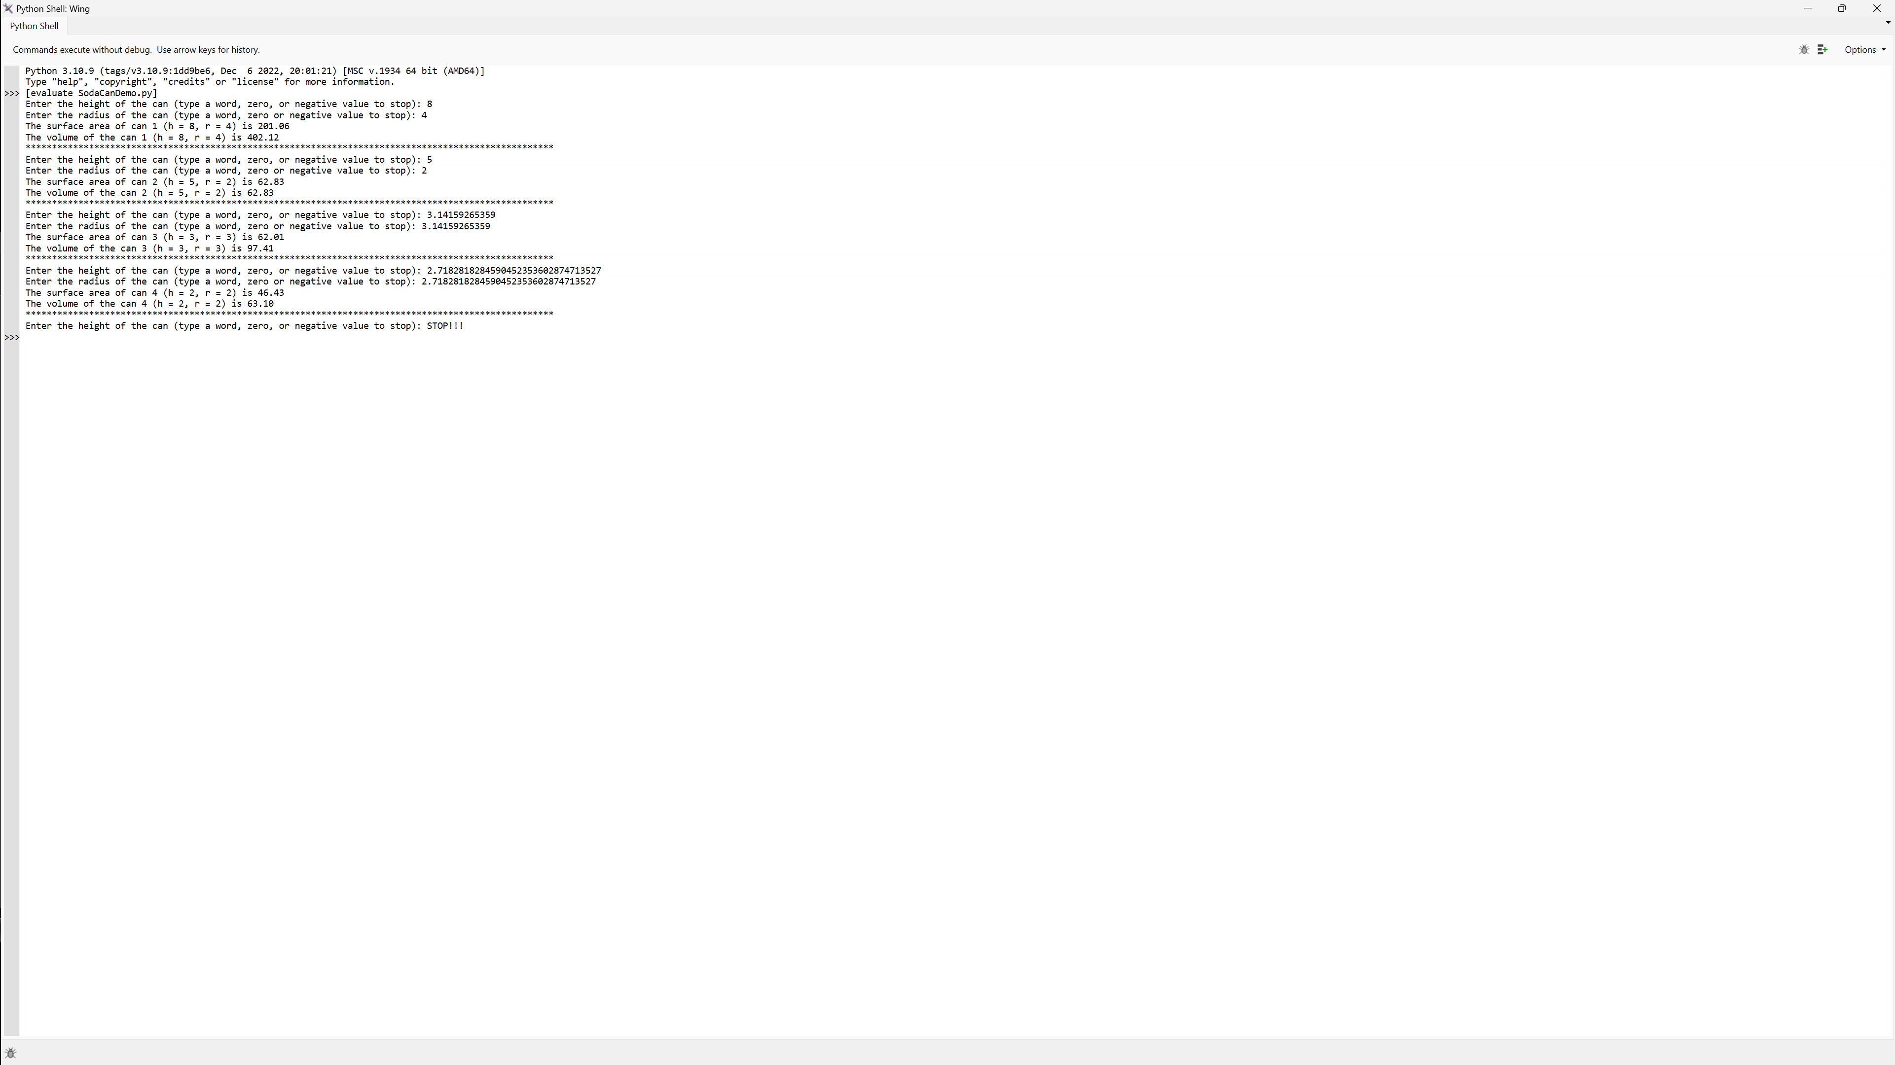

**Lab 9 – Written Code**

**IC1_SodaCan.py**

class SodaCan:  
 def __init__(*self*, height, radius, canNumber):  
 *self*.height = height  
 *self*.radius = radius  
 *self*.canNumber = canNumber  
  
 def getSurfaceArea(*self*):  
 import math  
 pi = math.radians(180)  
 surfArea = (2 * pi * *self*.radius * *self*.height)   
 + (2 * pi * *self*.radius * *self*.radius)  
 result = "%.2f" % surfArea  
 print("The surface area of can %d (h = %d, r = %d) is %s" %   
 (*self*.canNumber, *self*.height, *self*.radius, result))  
 return float(result)  
  
 def getVolume(*self*):  
 import math  
 pi = math.radians(180)  
 volume = (pi * *self*.radius * *self*.radius * *self*.height)  
 result = "%.2f" % volume  
 print("The volume of the can %d (h = %d, r = %d) is %s" %   
 (*self*.canNumber, *self*.height, *self*.radius, result))  
 return float(result)

**SodaCanDemo.py**

from IC1_SodaCan import SodaCan  
  
  
def main():  
 canNumber = 1  
  
 while True:  
 try:  
 height = input("Enter the height of the can (type a word, zero, or"  
 " negative value to stop): ")  
 height = float(height)  
 if height <= 0:  
 break  
 except ValueError:  
 break  
  
 try:  
 radius = input("Enter the radius of the can (type a word, zero or"  
 " negative value to stop): ")  
 radius = float(radius)  
 if radius <= 0:  
 break  
 except ValueError:  
 break  
  
 can = SodaCan(height, radius, canNumber)  
  
 can.getSurfaceArea()  
 can.getVolume()  
 print("*" * 100)  
  
 canNumber = canNumber + 1  
  
  
main()